**Compilers Part 4 Output**

Ryan Long

CS 4100 – Compilers – Fall 2020

Albert Brouillette

Table of Contents

A) IF/ELSE Statement code generation 2

B) WHILE Statement code generation 2

C) FOR Statement code generation 3

D) WRITELN Statement code generation 3

E) Expression, Term, and Factor Integer type code generation 4

* Relational Expression 4
* Simple Expression 5
* Term 6
* Factor 6

F) Interpreter function (executes all the quads) 7

G) Symbol Table dump function 9

* PrintSymbolTable 9
* Overloaded toString called by PrintSymbolTable 10

H) Quad dump function 11

I) Error recovery and resync functions 11

## IF/ELSE Statement code generation

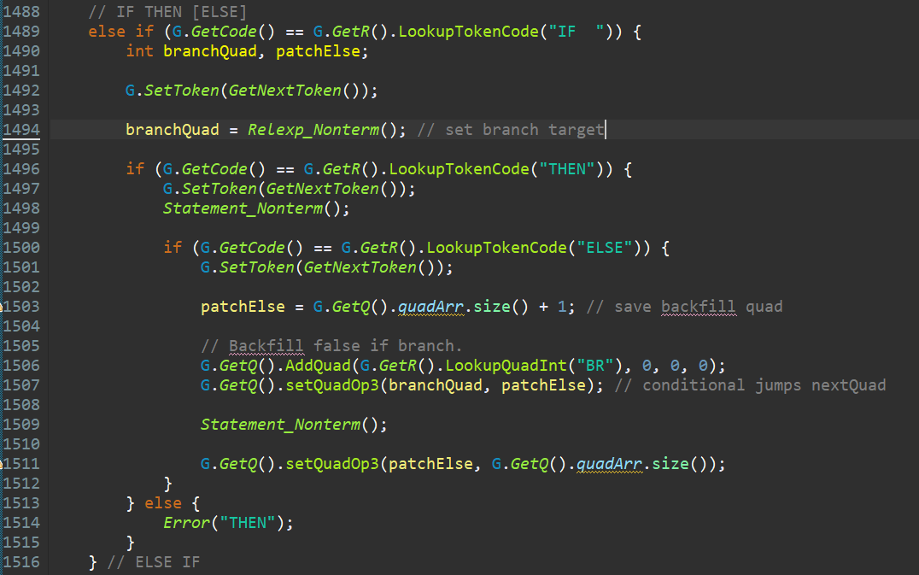

## WHILE Statement code generation

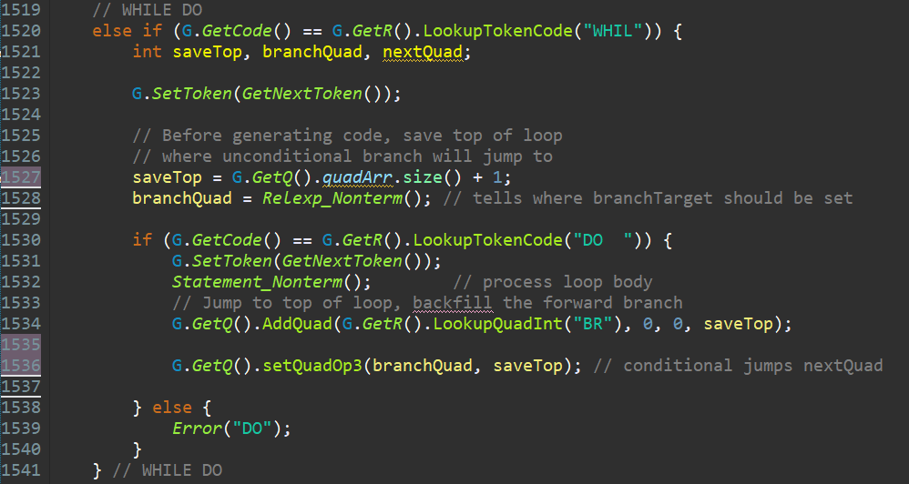

## FOR Statement code generation

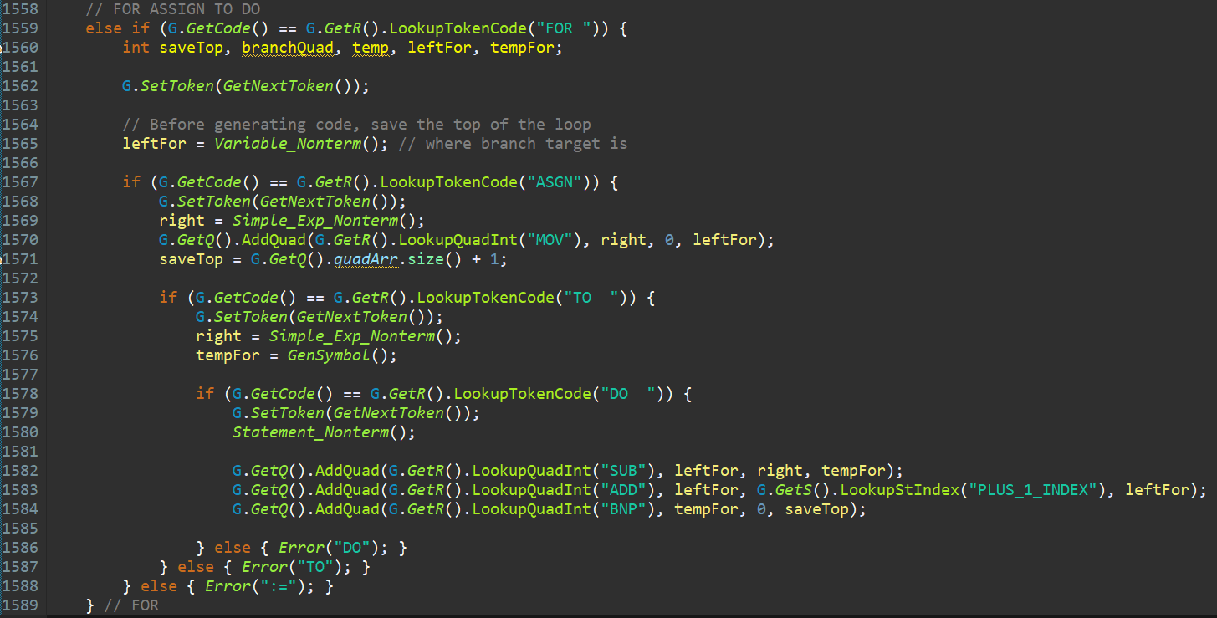

## WRITELN Statement code generation

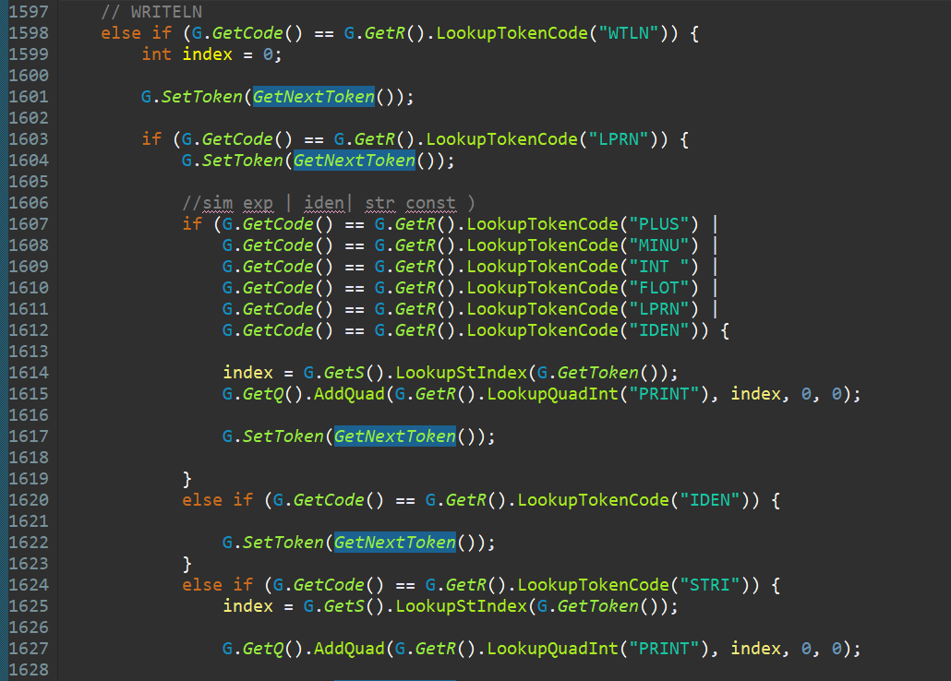

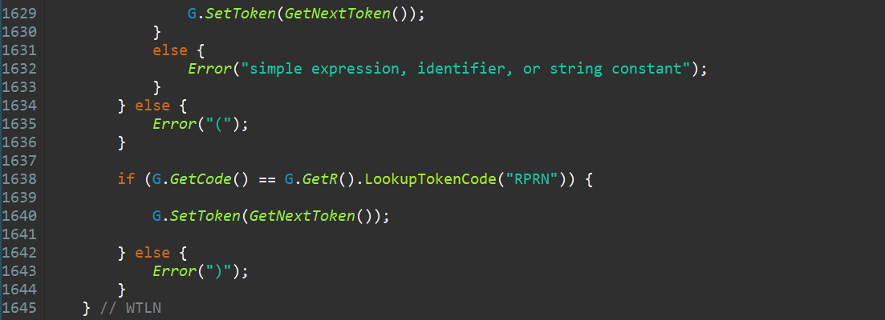

## Expression, Term, and Factor Integer type code generation

## Relational Expression

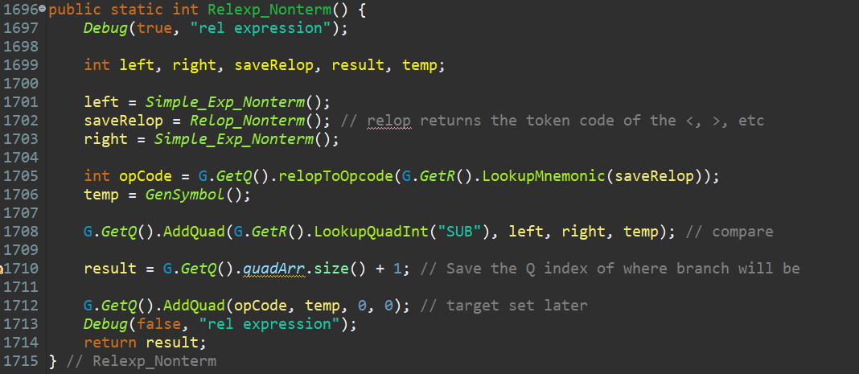

## Simple Expression

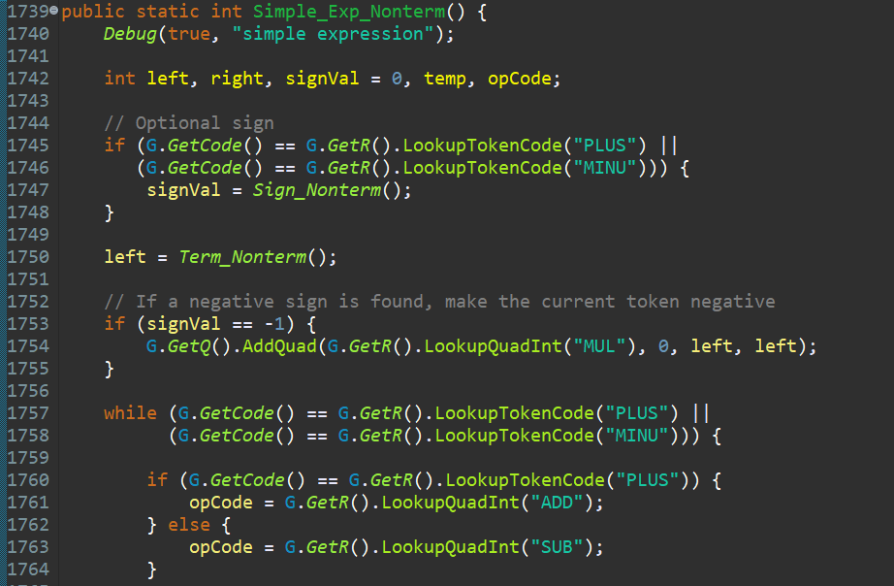

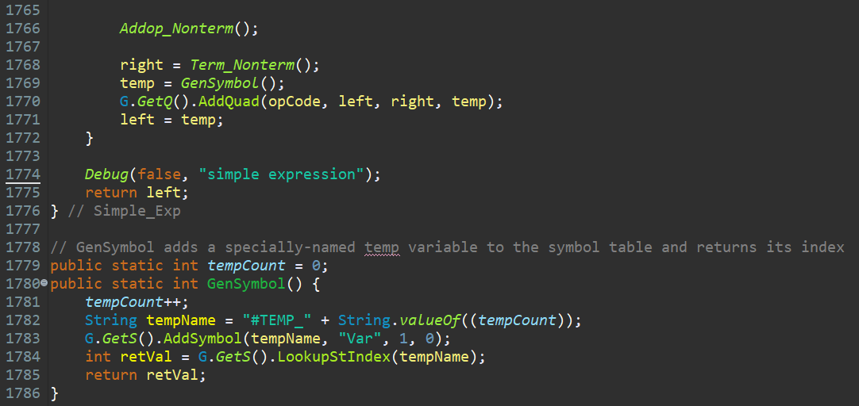

## Term

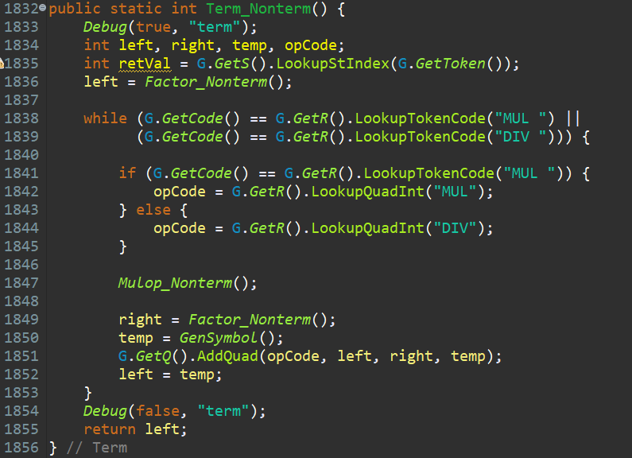

## Factor

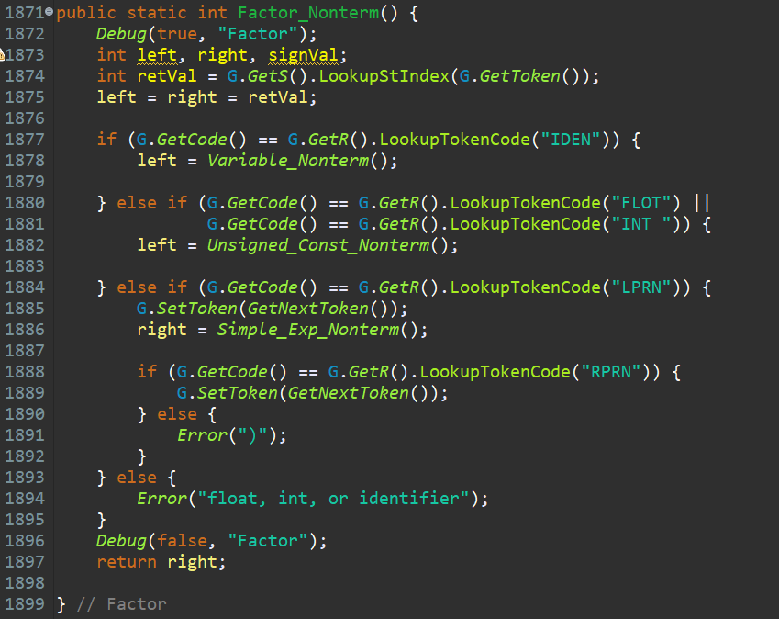

## Interpreter function (executes all the quads)

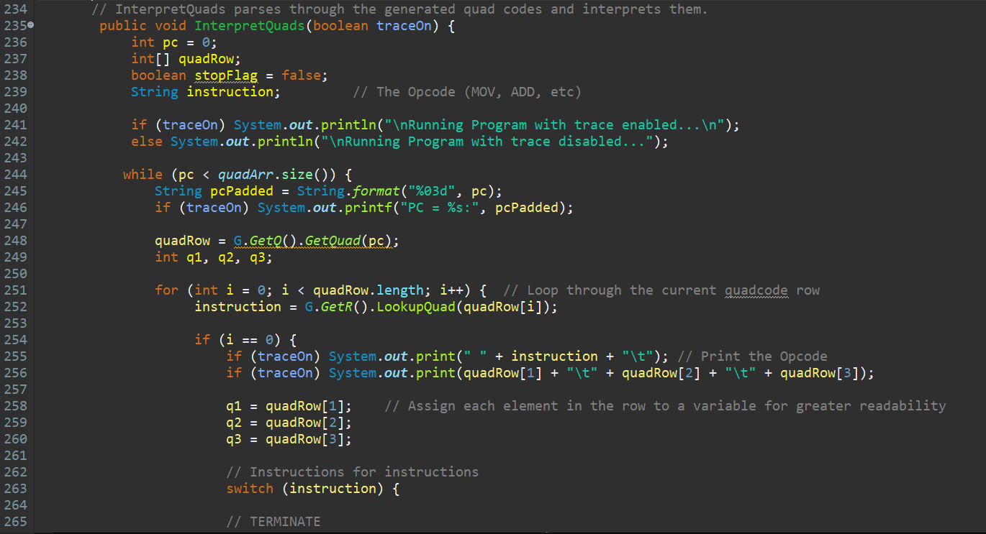

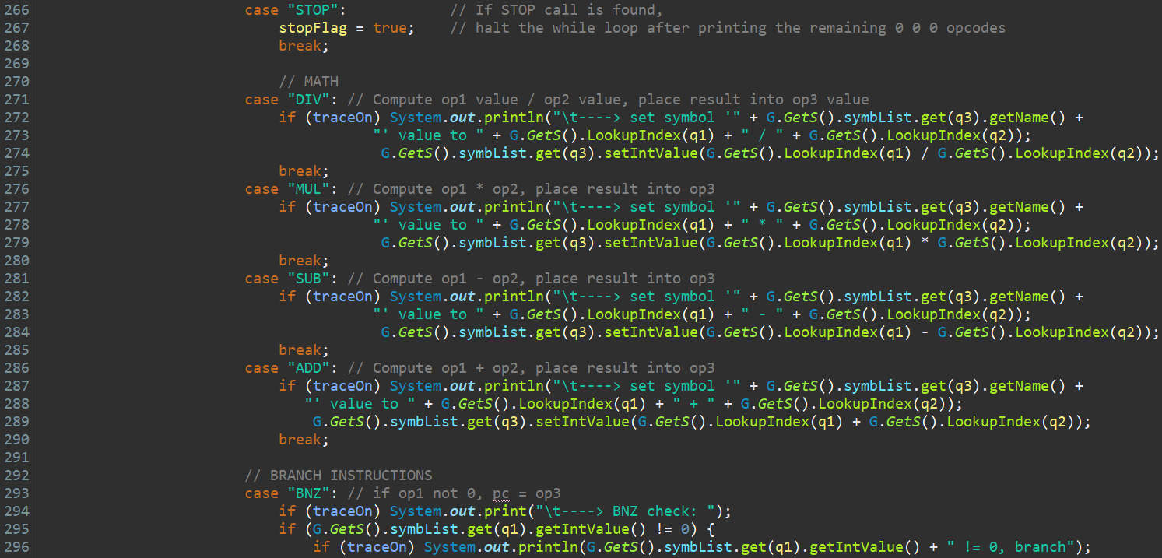

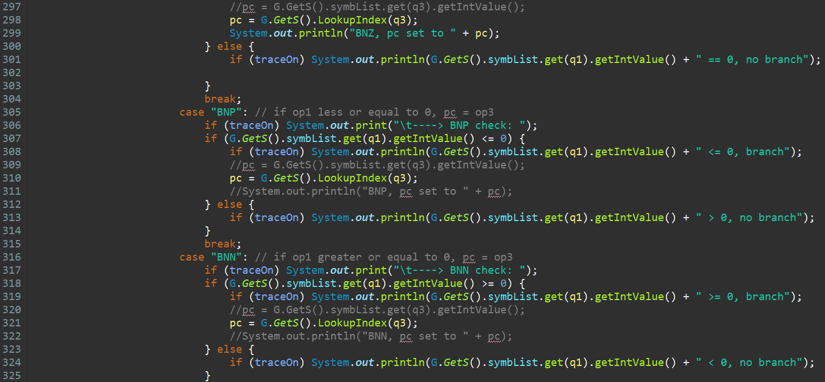

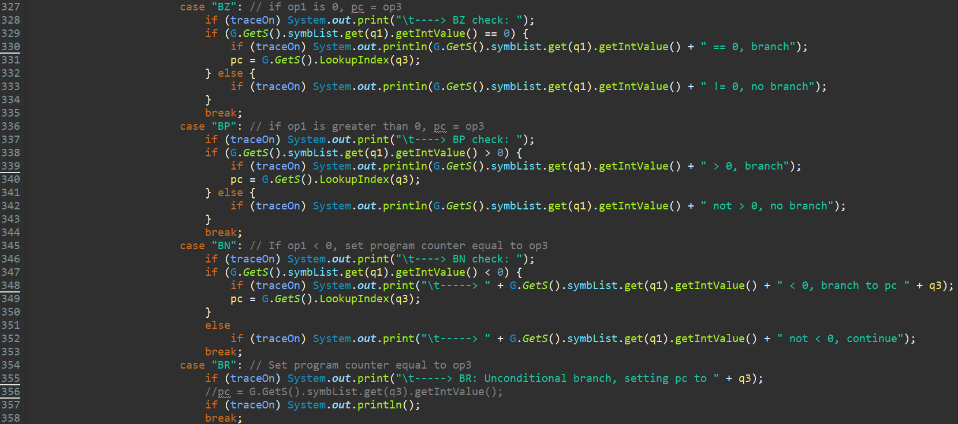

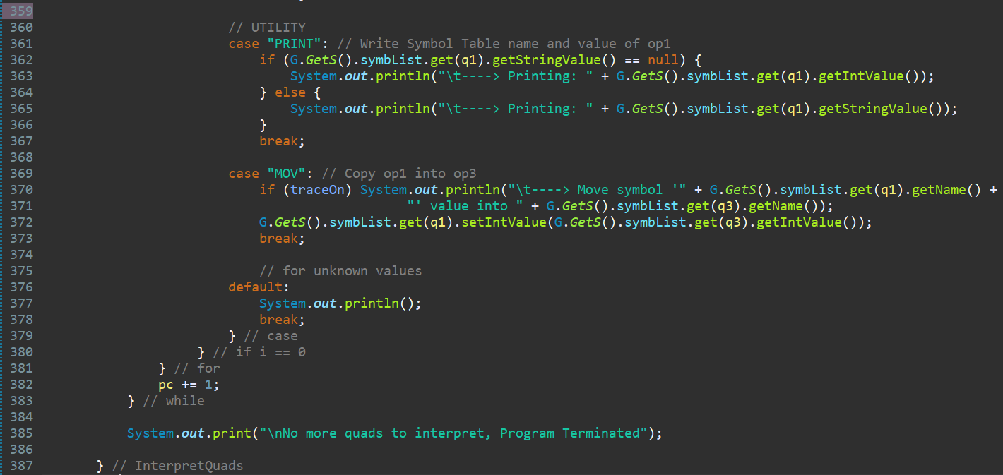

## Symbol Table dump function

## PrintSymbolTable

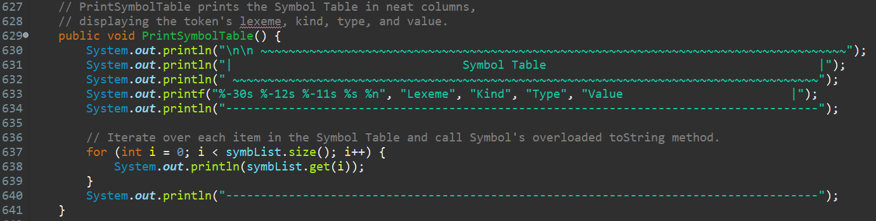

## Overloaded toString called by PrintSymbolTable

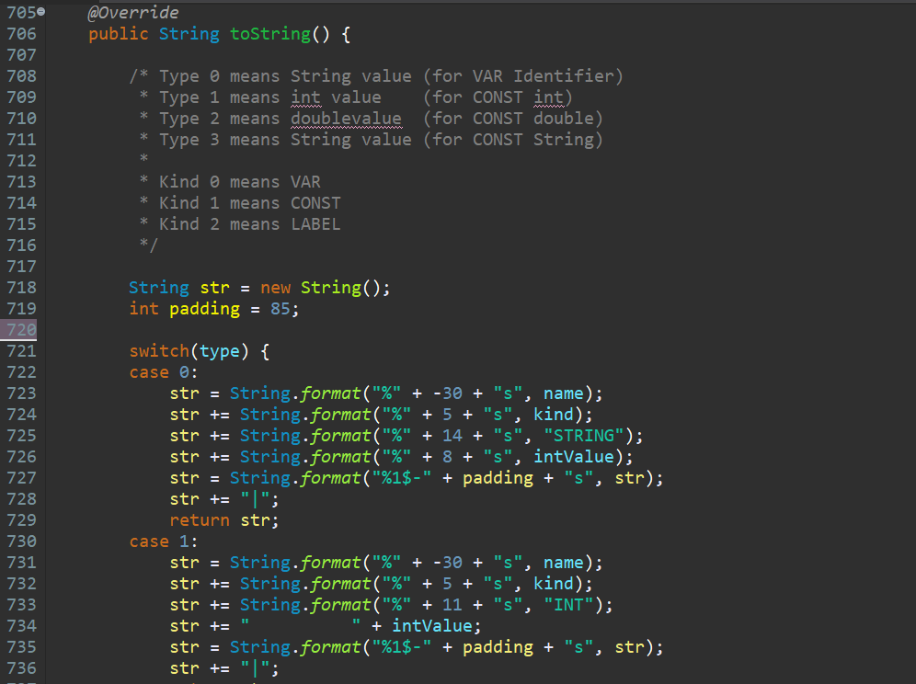

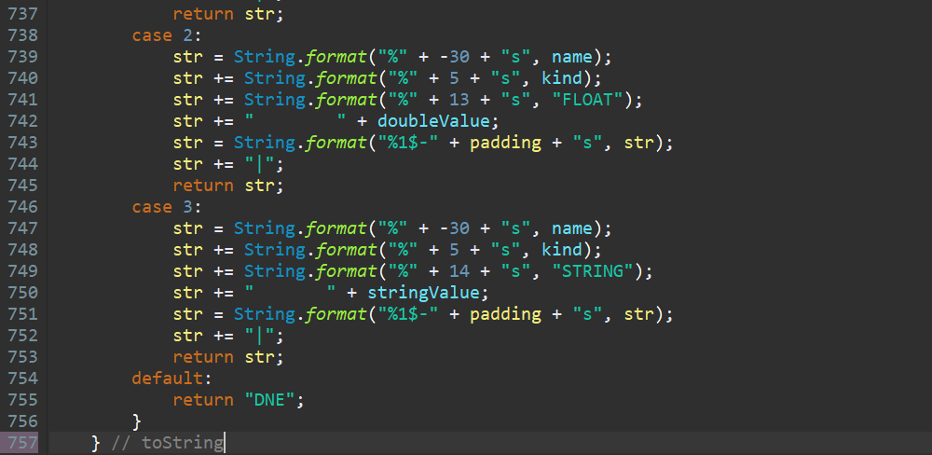

## Quad dump function

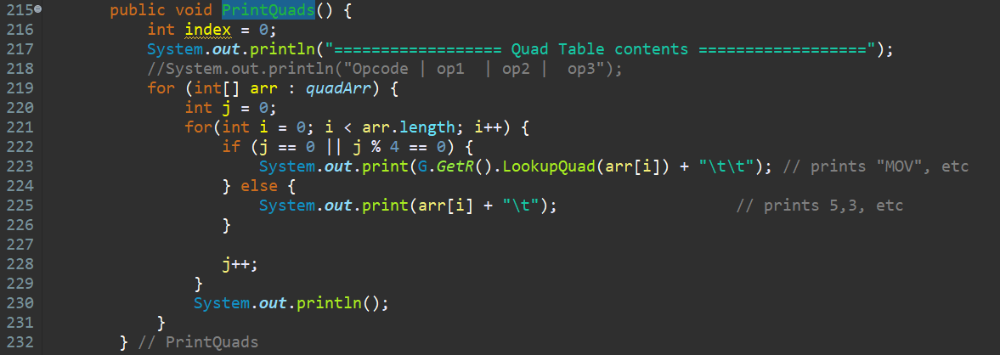

## Error recovery and resync functions

